 Application for Durable Medical Equipment (DME)

Are you SoonerCare eligible? ____YES ____NO SoonerCare Number: ____________________

How did you hear about us? _____Word of mouth _____ Social Worker/Case Manger _____ Internet search

_____Poster _____ Flyer _____ Social media _____Conference _____Organization _________ Other

Name: _____________________________________________ Birthdate: _____________________

________________________________________________________________________________

Address City Zip

________________________________________________________________________________

Phone Alternate Phone E-mail Address

________________________________________________________________________________

Item(s) Requested

Will the requested item need to be _____ Pediatric _____Adult _____Bariatric (over 250 pounds)

*If the DME you need requires measurements, please complete the “Customer Measurements” Form on the last page to be included with this application.*

Have you used this equipment before? ____ YES ____ NO

Will this equipment be the initial piece or a replacement? _____Initial _____ Replacement

Do you have a prescription from your doctor for this DME? ____ YES ____ NO

### *Refer to the table on next page, “DME Chart”.*

If required, do you have the additional documentation? ____YES ____ NO

*Refer to the table on the next page, “DME Chart”.*

This equipment will be used for me or my family member’s personal use and will not be sold. To the best of my knowledge, all information is true and accurate. I understand not all accessories may be available with the DME and may require contacting someone other than OKDMERP at my own cost.

________________________________________________________________________________

Applicant Signature or Authorized Representative Date

**Oklahoma Durable Medical Equipment Reuse Program**

3325 North Lincoln

Oklahoma City, OK 73105

Phone 405-523-4810 / Fax 405-523-4811

http://okabletech.okstate.edu

**Oklahoma Durable Medical Equipment Reuse Program**

3325 North Lincoln

Oklahoma City, OK 73105

Phone 405-523-4810 / Fax 405-523-4811

http://okabletech.okstate.edu

**Oklahoma Durable Medical Equipment Reuse Program**

3325 North Lincoln

Oklahoma City, OK 73105

Phone 405-523-4810 / Fax 405-523-4811

http://okabletech.okstate.edu

**Oklahoma Durable Medical Equipment Reuse Program**

3325 North Lincoln

Oklahoma City, OK 73105

Phone 405-523-4810 / Fax 405-523-4811

http://okabletech.okstate.edu

**Oklahoma Durable Medical Equipment Reuse Program**

3325 North Lincoln Blvd.

Oklahoma City, OK 73105

Phone 405-523-4810 / Fax 405-523-4811

<http://okabletech.okstate.edu>

 **DME CHART**

|  |  |  |  |  |
| --- | --- | --- | --- | --- |
| **DME** | **PRESCRIPTION REQUIRED?** | **DOCUMENTATION REQUIRED IN ADDITION TO PRESCRIPTION** | **NOT**  **INCLUDED** | **MEASUREMENT**  **PAGE (Page 3)**  **MUST BE COMPLETED** |
| Bath Bench | No | No |  | YES |
| Blood Pressure Monitor | No | No |  | NO |
| CPAP | Yes | Sleep Study | Masks, hoses, and filters | NO |
| Commodes | No | No |  | YES |
| Gait Trainers | Yes | Evaluation Report from ATP/OT/PT |  | YES |
| Hospital Beds  (elec. & semi elec) | Yes | No | Mattress | YES |
| Knee Walkers | No | No |  | NO |
| Nebulizers | Yes | No | medication and tubing | NO |
| Patient Lifts | Yes | Evaluation Report from ATP/OT/PT | Slings | YES |
| Quad Canes | No | No |  | YES |
| Scooters (POV) | Yes | Evaluation Report from ATP/OT/PT |  | YES |
| Shower Chairs | No | No |  | YES |
| Standers | Yes | Evaluation Report from ATP/OT/PT |  | YES |
| Walkers  (and rollators) | Yes | No |  | YES |
| Wheelchairs (manual) | Yes | No |  | YES |
| Wheelchairs (power) | Yes | Evaluation Report from ATP/OT/PT |  | YES |

Refer to the chart below to find the item requested. Follow the line across to see what is required for a completed application. Incomplete applications are not considered until all requirements are met.

***If you are not currently working with a therapist, please contact OKDMERP for potential sources to help with the evaluation report required for certain DME.***

Oklahoma Durable Medical Equipment Reuse Program

3325 North Lincoln Boulevard

Oklahoma City, OK 73105

Phone 405-523-4810 / Fax 405-523-4811

<http://okabletech.okstate.edu>

### Customer Measurements

The purpose of this form is to obtain rudimentary measurements to decrease the frequency of false deliveries. There are many websites available for instruction on how to obtain proper measurements. **Please note that these measurements are not intended to guarantee appropriate assessment or fit**. The person should be seated on a firm surface with feet flat. Provide body measurements, not chair measurements.

**Height:______________________Weight___________________________________**

**A. Seat surface to top of head**: Measure from seat surface (where buttocks contact the seat surface) to top of head. This measurement is especially useful for tilt systems, recliners, and those with headrests or high backs.

**B. Seat surface to top of shoulder**: Measure from seat surface (where buttocks contact the seat surface) to top of shoulder. This measurement is especially useful for wheelchairs with high backs.

**G. Behind knee to back of hips**: Measure from seat back (where buttocks contact the seat back) to just back of knees when knees are bent at 90 degrees and subtract about 2 inches.

**H. Heel to back of knee**: Measure from floor (where bottom of heel contacts floor) to back of the knee when knees are bent at 90 degrees. If the person intends to propel with his feet, you want to be sure that the wheelchair seat is close enough to the floor to work. Hemi chairs are closer to the floor than standard chairs. You can also change tires on some wheelchairs to get closer to the ground.

**M. Lap width**: Measure the hips at the fullest part. You can add up to 2 inches to the number depending on the amount of room the individual wants. If you were to place two books on either side of the hips, you would measure straight between the two books instead of curving up and over the lap like a seatbelt would.

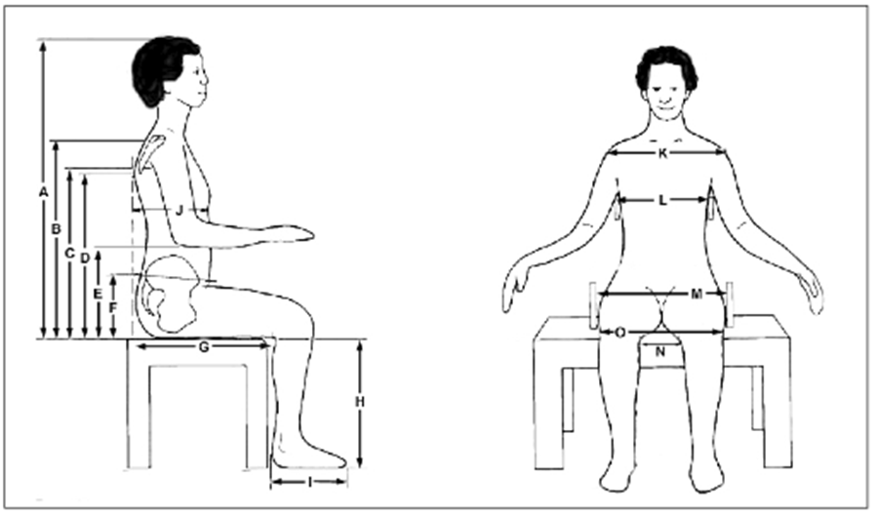

M (Lap Width)

Does wheelchair need seatbelt? _____YES _____NO

Does wheelchair need leg rests? _____YES _____NO

Does wheelchair need elevated leg rests? _____YES _____ NO

Oklahoma Durable Medical Equipment Reuse Program

3325 North Lincoln Boulevard

Oklahoma City, OK 73105

Phone 405-523-4810 / Fax 405-523-4811

http://okabletech.okstate.ed